

**本科实验报告**

|  |  |
| --- | --- |
| 课程名称： | 计算机体系结构 |
| 姓 名： | 周炜 |
| 学 院： | 计算机科学与技术学院 |
| 系： | 计算机科学与技术系 |
| 专 业： | 计算机科学与技术 |
| 学 号： | 3210103790 |
| 指导教师： | 卜凯 |

2023年 12 月 9 日

Lab 5: Pipelined CPU supporting multi-cycle operations

周炜 3210103790

1. **Purpose**

* Understand the principle of piplines that support multicycle operations.
* Master the design methods of piplines that support multicycle operations.
* Master verification methods of pipelined CPU supporting multicycle operations.

1. **Task**

* Redesign the pipelines with **IF/ID/FU/WB stages** and FU stage supporting multicycle operations.
* Redesign of CPU Controller.
* Verify the Pipelined CPU with program and observe the execution of program.

This experiment will be based on the SWORD development board, equipped with an XC7K325TFFG6762L FPGA.

We have been provided with a Verilog project that complements a CPU core and other components for debugging on this board. The CPU core should be capable of handling both integer and floating-point operations. Most of the project parts have already been completed. However, there are still some units that require our attention. These units include:

FU_ALU.v: This module is responsible for handling integral arithmetic operations.

FU_div.v: This module is designed to handle floating-point division operations.

FU_mul.v: This module is responsible for managing floating-point multiplication operations.

FU_mem.v: This module is in charge of handling memory operations.

FU_jump.v: This module is dedicated to managing branch operations.

RV32core.v: T his is the f lo at point CPU top m o d u le.

1. **Experimental process**
   1. **Float-point CPU Architecture**

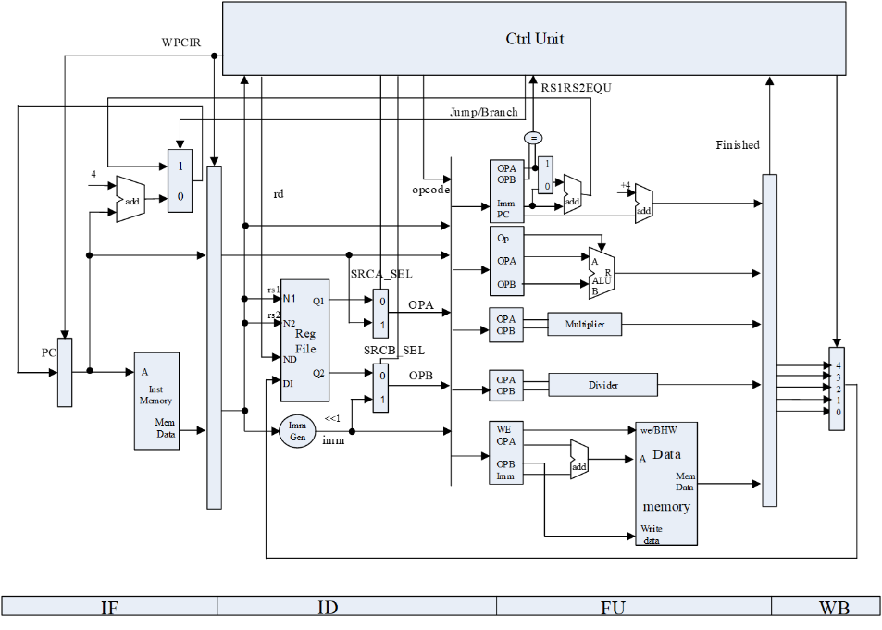

This multi-cycle pipeline is divided into 4 stages, IF/ID/FU/WB. The IF stage fetches instructions, the ID stage decodes, read operands, and the FU stage performs computation with branch, integer computation, multiplication, division, and memory operations (load/store memory). Finally, after processing writeback, the result is written back to the registers.

In our experiment, to streamline the design, we must wait for all instructions to complete execution before issuing another instruction.

* 1. **Detailed Function Unit**

For clarity, we will exclude certain preset code segments and focus solely on analyzing the code blocks that require completion.

**3.2.1 RV32core. v**

Just follow the structure diagram in 3.1 to connect the wires

The first is the instruction to be filled in at the **ID** stage.

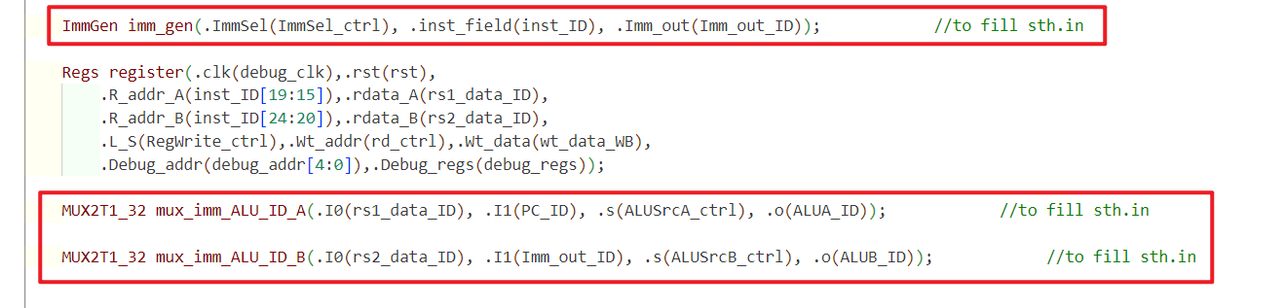

Then there are the instructions to be filled in in the **WB** stage

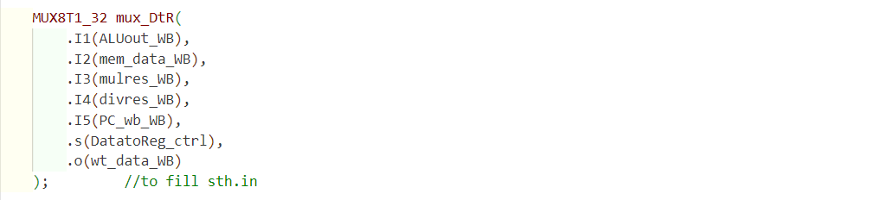

**3.2.2 FU_ALU.v**

First look at the ALU, which is the integer computation unit. First a state register is defined, which is used to indicate the occupancy status of this computational unit and whether it is finished or not.

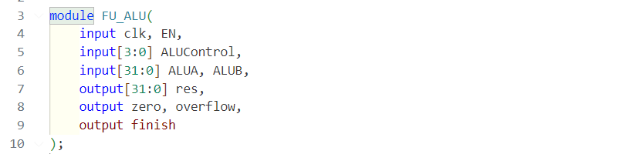

Inside the ALU, the two operands are A and B. The operation to be performed is specified by the Control signal. The instruction enters the ALU unit for computation, and in the initial state, when the ALU is enabled and the ALU is idle, we need to assign values to A, B, and Control.

The only task remaining for us to address is specifying the initial state of the ALU. Given that ALU operations only take one cycle in the FU stage, we can document it as follows.

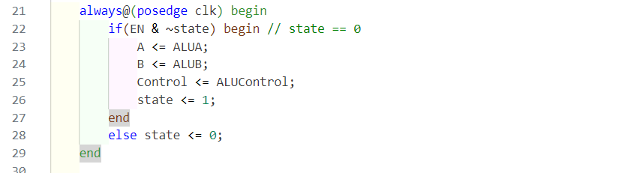

**3.2.3 FU_mem.v**

Noting that the state is 2-digit.

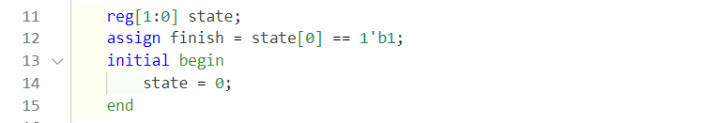

Similar to the previous scenario, another aspect we need to address is defining the initial state and state transitions for memory operations. Since memory operations require 2 cycles in the FU stage, we can describe it as follows.

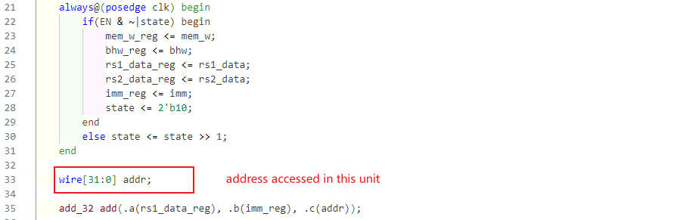

**3.2.4 FU_jump.v**

Similar to the previous cases, there's a need to specify the initial state and state transitions for branch operations. Since branch operations take only 1 cycle in the FU stage, we can document it as follows:

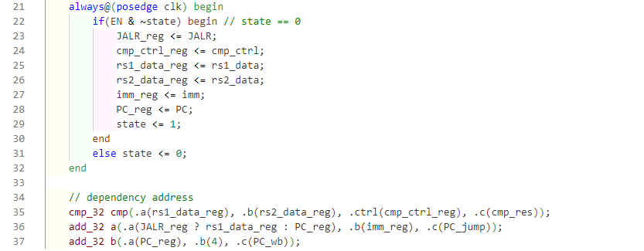

**3.2.5 FU_mul.v**

Then there is the MUL part, which calculates the multiplication of floating point numbers (in Multiplier, the same thing), the multiplication of floating point numbers takes 7 clock cycles.

Here a 7-bit register state, into the calculation, the state of the highest bit is set to 1, and then every clock cycle, this 1 to the right one shift, the state of the lowest bit is 1 when the calculation is over.

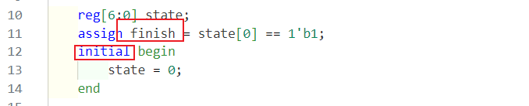

The sole task remaining is to specify the initial state and state transitions for floating-point multiplication operations. Given that floating-point multiplication operations take 8 cycles in the FU stage, we can express this as follows:

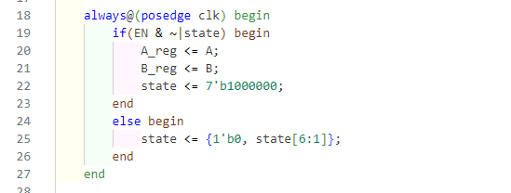

**3.2.6 FU_div.v**

Then comes division, although division is also multi-cycle, the state defined here is only one bit. This is because the res_valid signal is emitted at the end of the divider's computation, so we don't need to do the execution cycle counting by ourselves

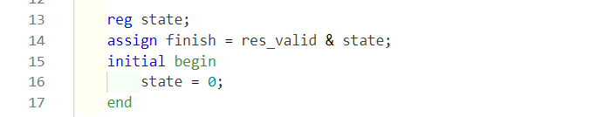

Similar to the previous instances, the only task remaining is to define the initial state and state transitions for floating-point divide operations. Given that floating-point divide operations involve a divider and remain in the FU stage until the valid signal is set, we can express this as follows:

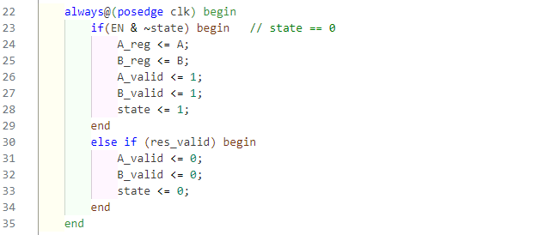

* 1. **Data Hazards Resolve**

The handling of these hazards is reflected in the control unit's code.

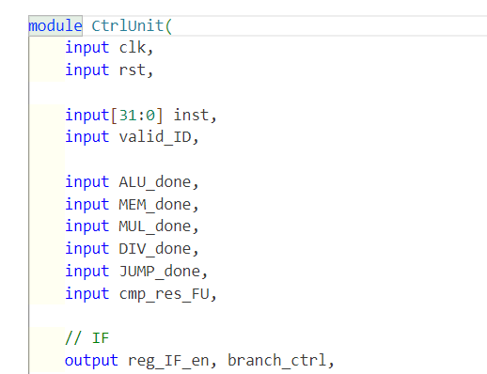 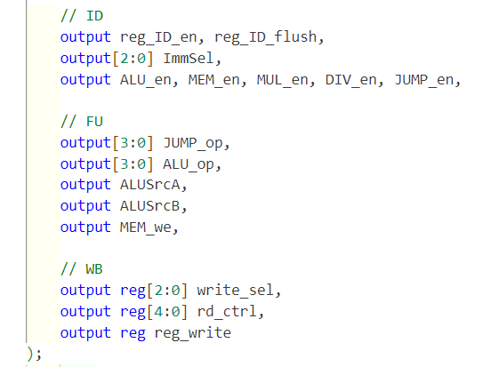

For the IF stage, we need to control whether it is stalled or not and the selection of the next instruction.

In the ID stage, we need to control the ID's STALL, FLUSH, IMMEDIATE, and determine the computation unit needed for the computation according to the instruction type, which is the enable signal in the last line here (ALU_en, MEM_en, MUL_en, DIV_en, JUMP_en).

In the FU stage, the control unit passes the number of operations to be calculated and decides on the type of operation.

In the WB stage, it is decided here whether to write back or not, to what register and where the data written back is coming from (is it ALU, MEM, MUL, DIV, JUMP).

Looking at the inputs to the ctrl unit, there are instructions, and signals that need to be passed to the ctrl unit after the Fu stage has completed its calculations.

Inside this experiment, we need to wait **until both the FU and WB** of an instruction have finished executing before the next instruction can enter the FU, so as to avoid data hazard

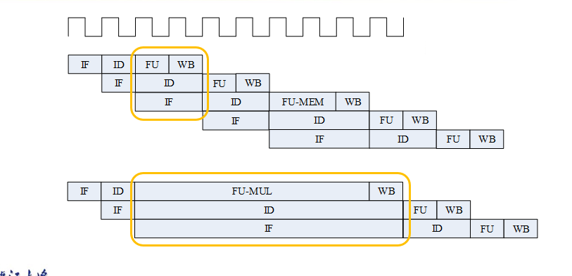

Specifically in CtrilUnit.v the code is

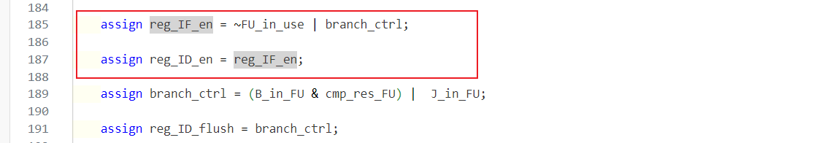

If the branch actually needs to jump, it needs to kill two instructions,. In this experiment, we used predict-not-taken and the branch moved to the FU stage to compute.[1]



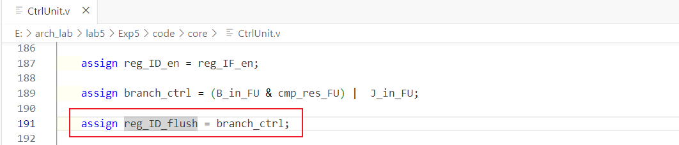

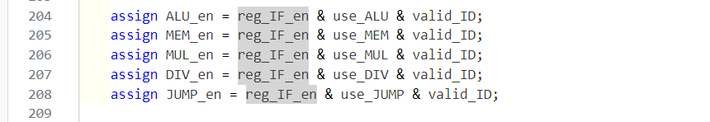

Reg_ID_flush作为output输入到REG_ID中

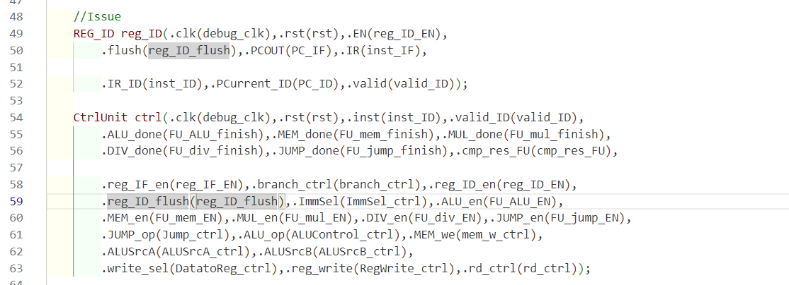

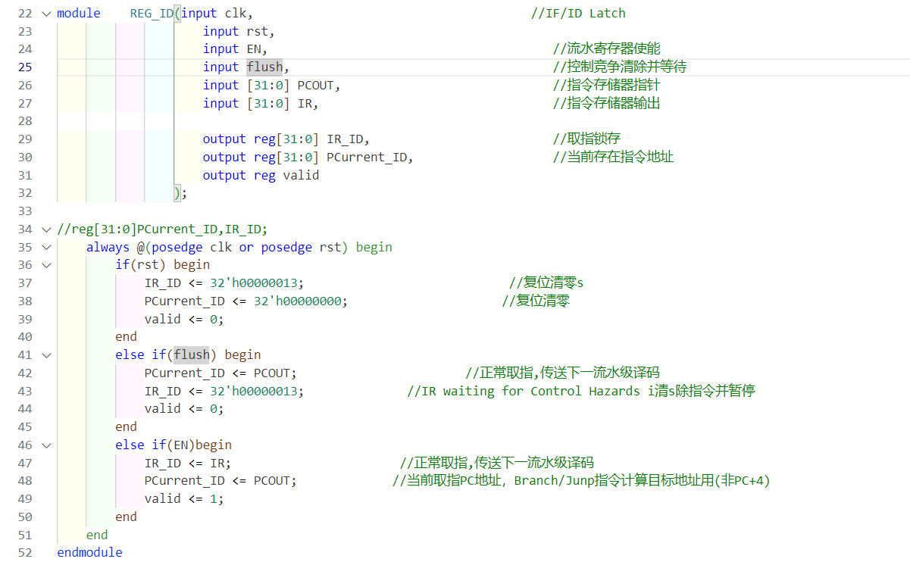

1. **Result and Analysis**

**4.1 Simulation results**

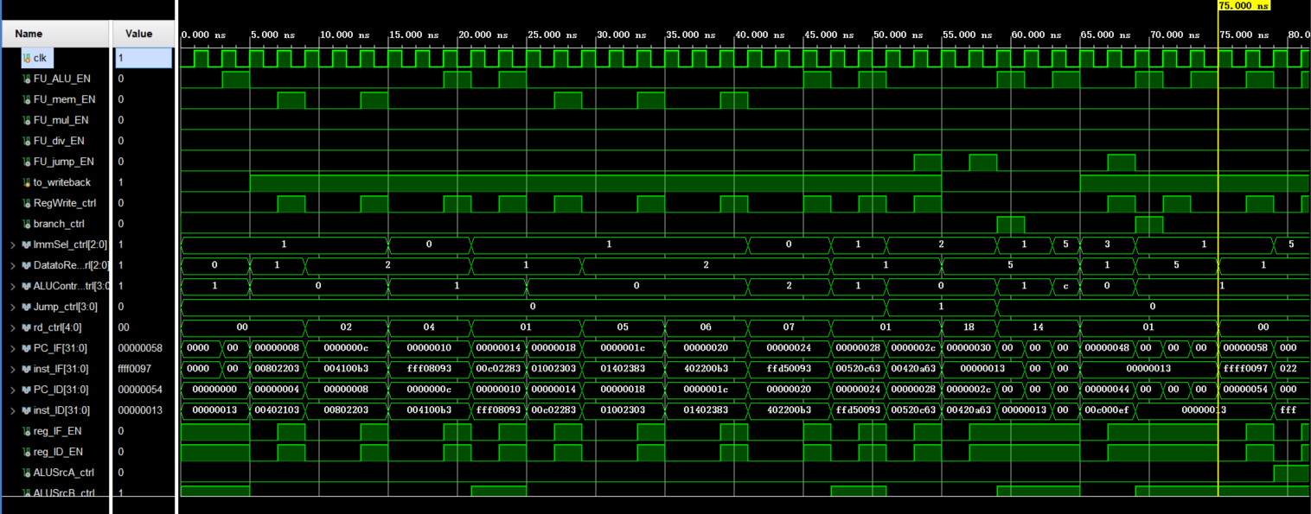

Here is a division instruction, we see a signal on it, which means that the division module of the FU is available, and then the FU phase follows

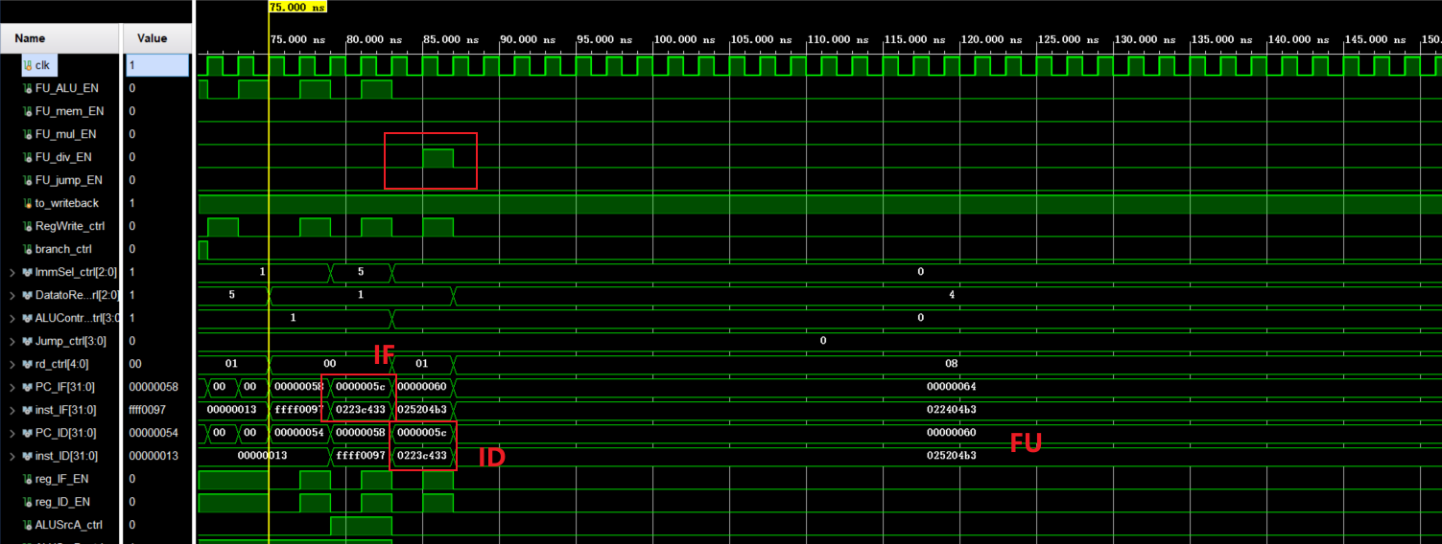

Between 163 and 179 nanoseconds, the CPU core takes 8 cycles to complete a floating-point multiplication operation. It's worth noting that at 177-179 nanoseconds, the signal FU_mul_EN is activated, signifying the handling of the floating-point multiplication operation. Subsequently, the CPU is free to process the next instruction after 179 nanoseconds. This observation suggests that the process is running smoothly.

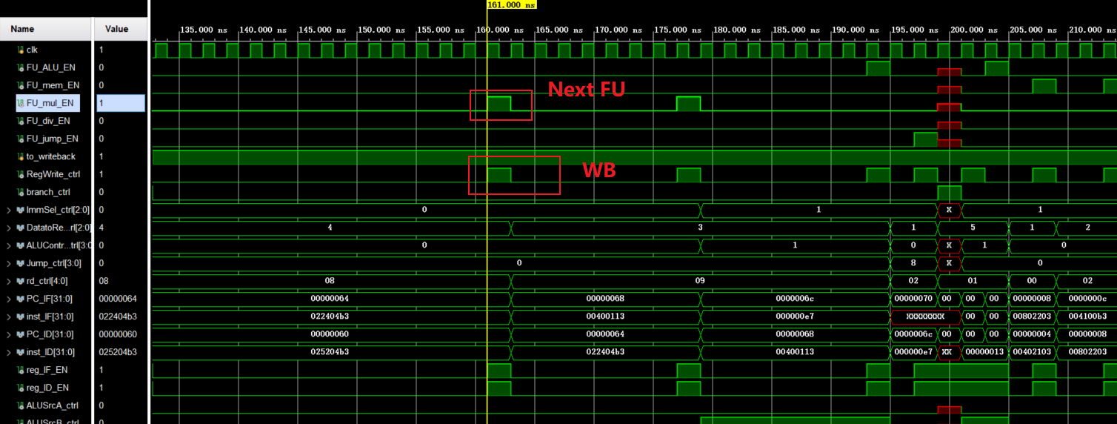

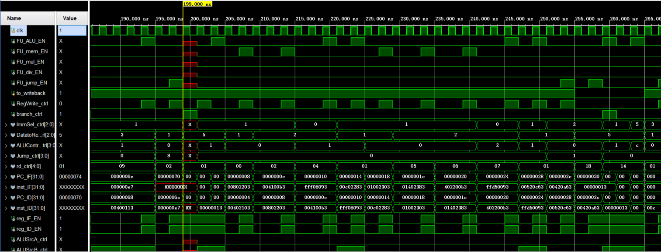

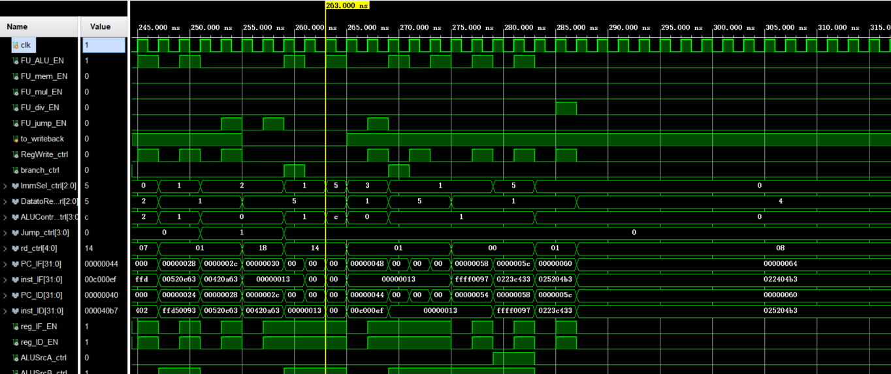

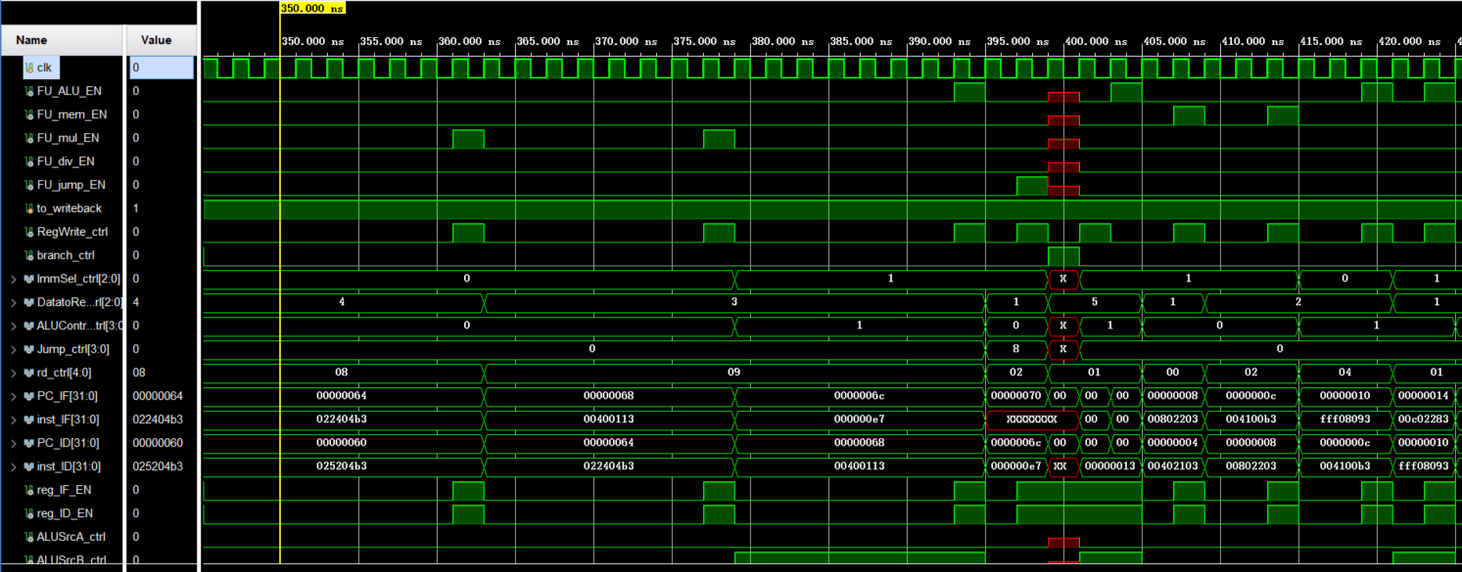

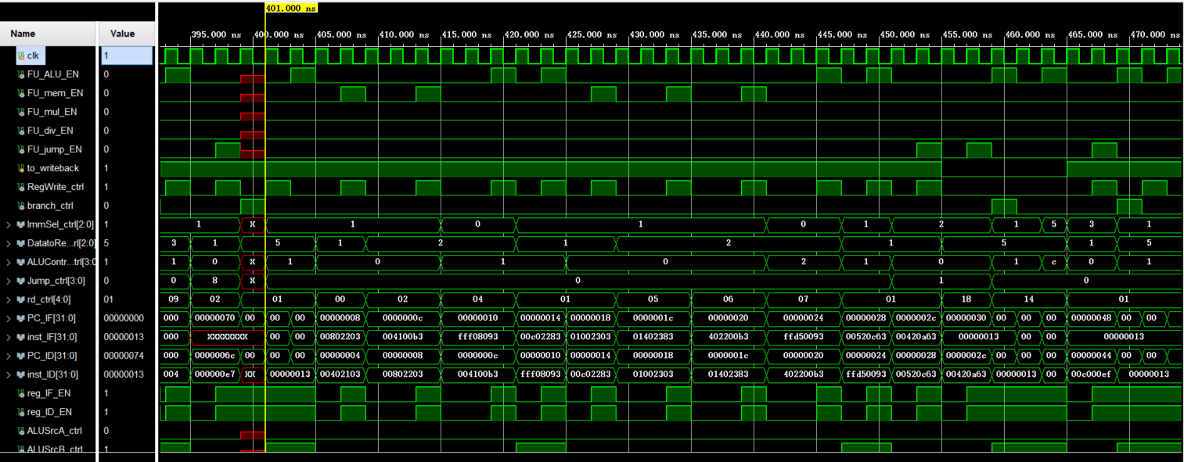

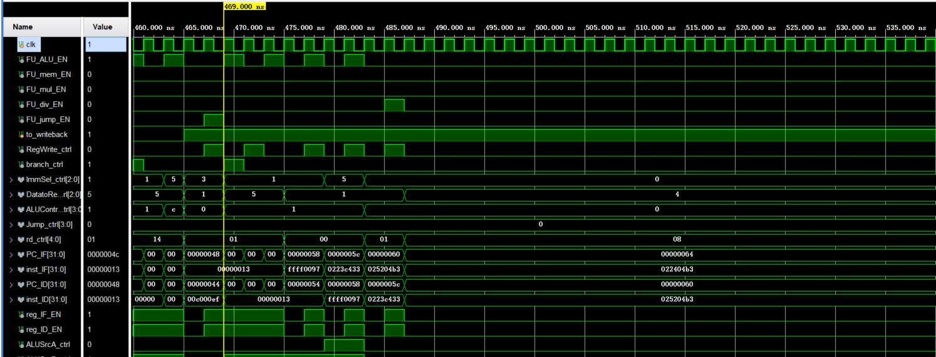

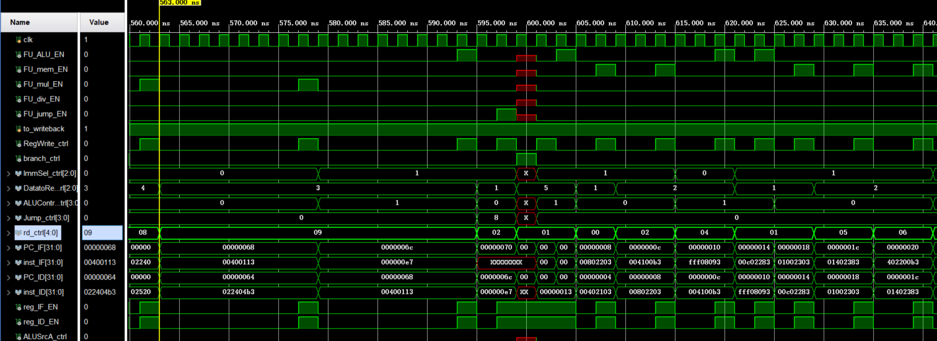

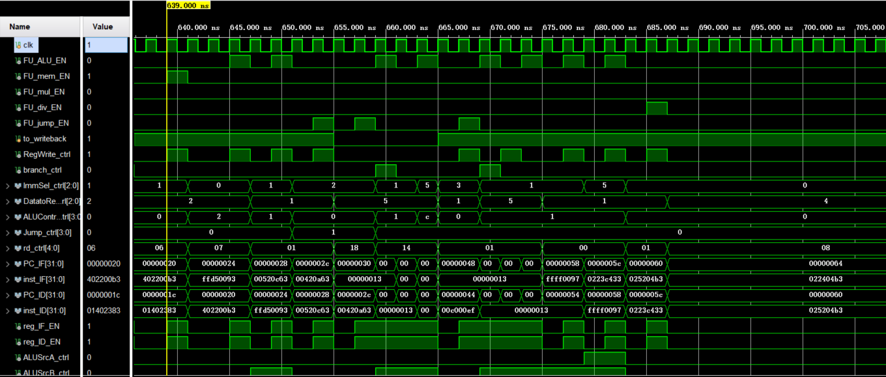

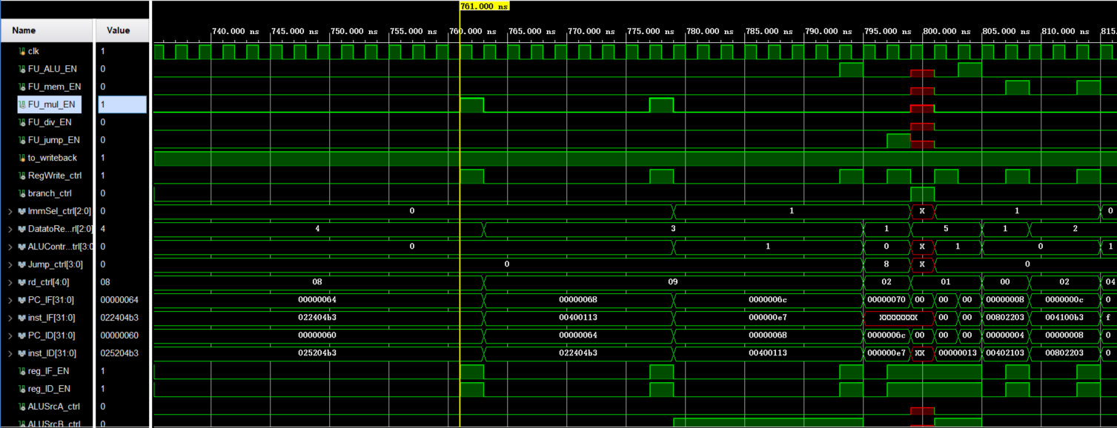

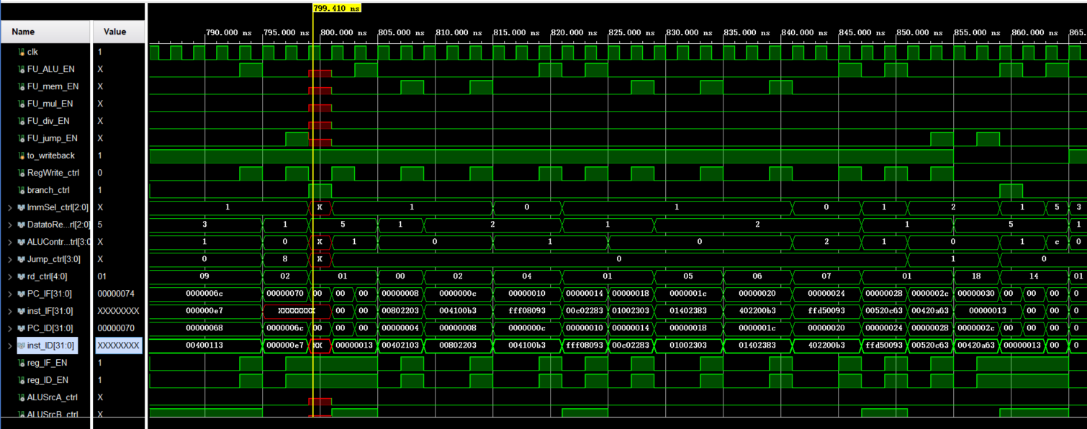

**4.2 Physical verification**

The lower plate results are similar to the simulation

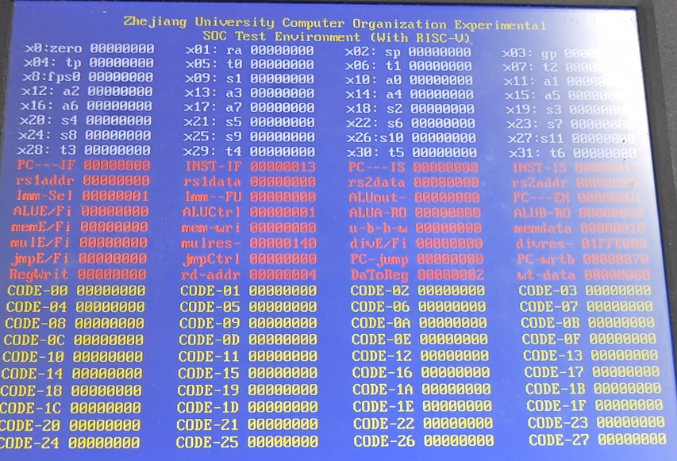

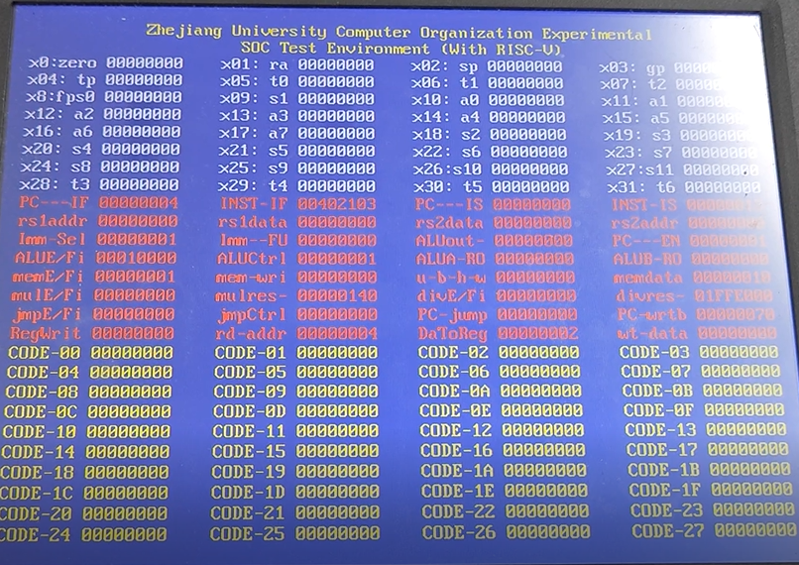

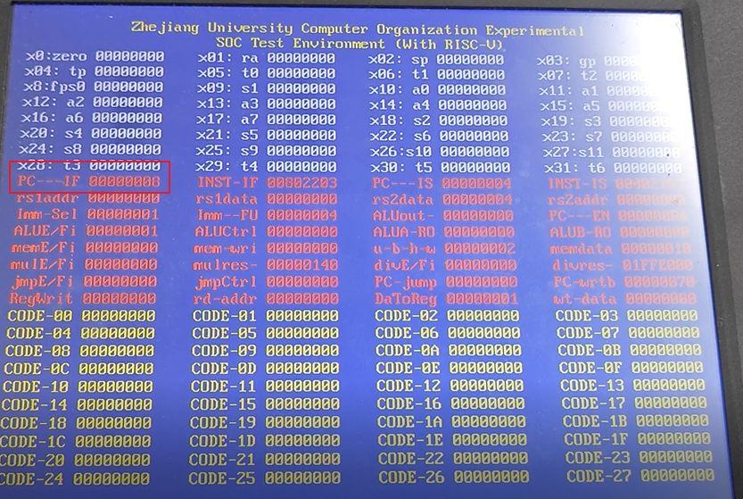

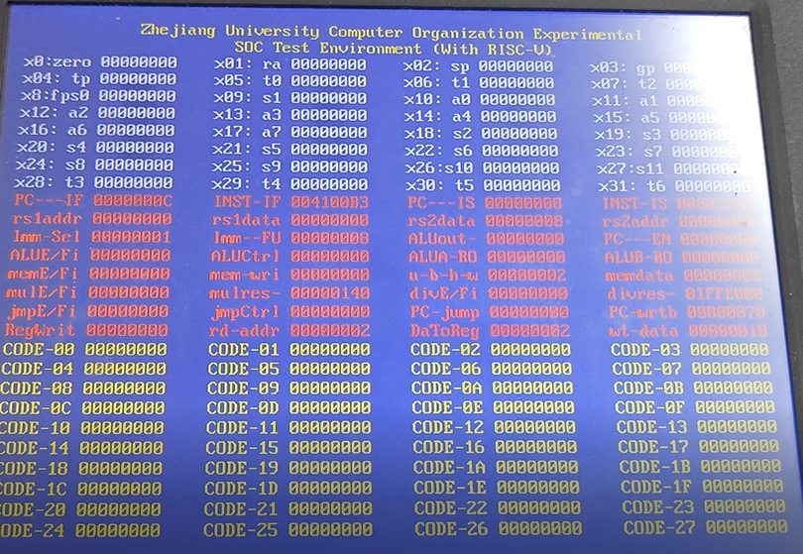

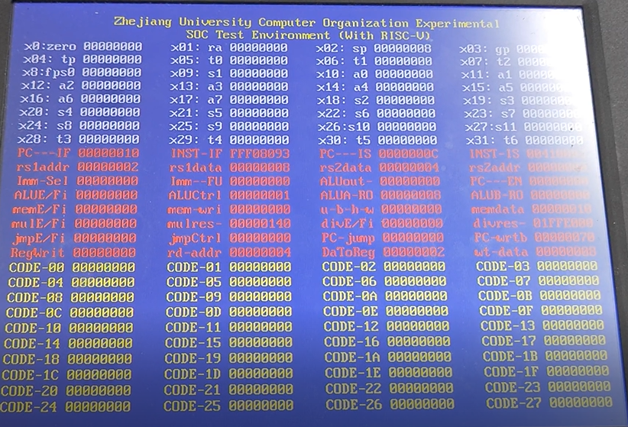

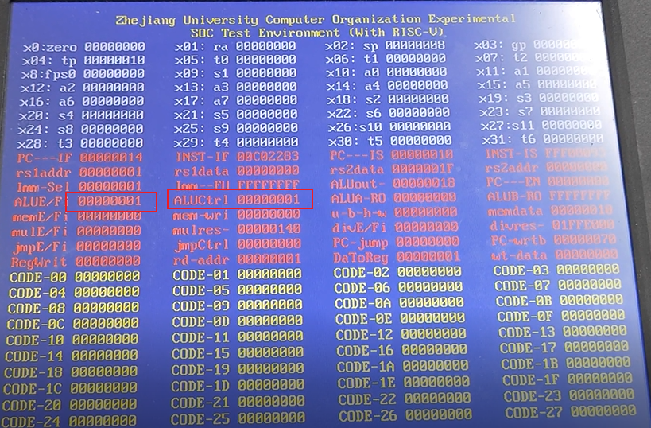

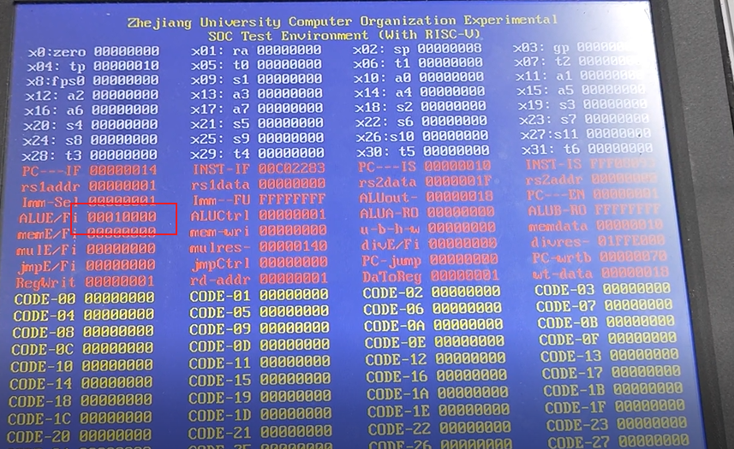

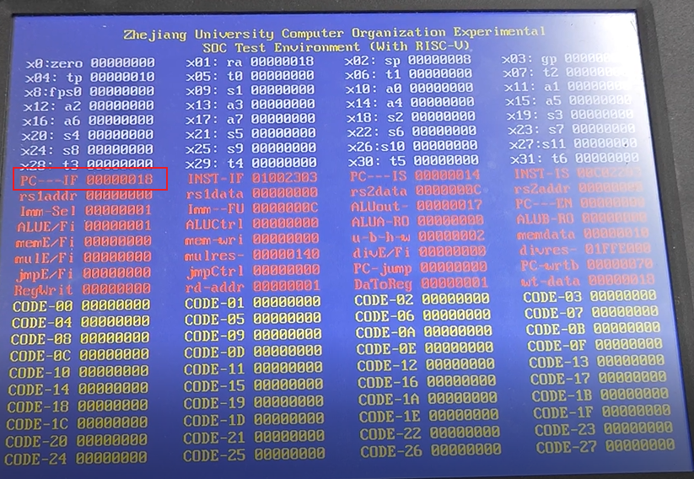

1. **Discussion and thoughts**

In this experiment, I successfully implemented a floating-point CPU that supports multicycle operations and gained valuable insights into the design of floating-point functions in architecture. Overall, the experiment was a success.

1. There may be something not quite right with this picture, Fu flushes when it's finished processing